# Lab-10-2: AWS Networking Checkpoint

# 8 points

# Submission By: 24 Sept 5pm on Teams-> Assignment.

# Name: Anthony Legg

# Objectives

* Setup virtual networking with subnets on AWS
* Deploy web application on aws subnet



--------------------------------------------------------------------------------------------------

# Create a Virtual Private Network (VPC) and host a webserver inside a public subnet

# In this task, you are going to setup a virtual network in AWS, that has both private and public subnets that spans multiple availability zones.

# The network is shown below:

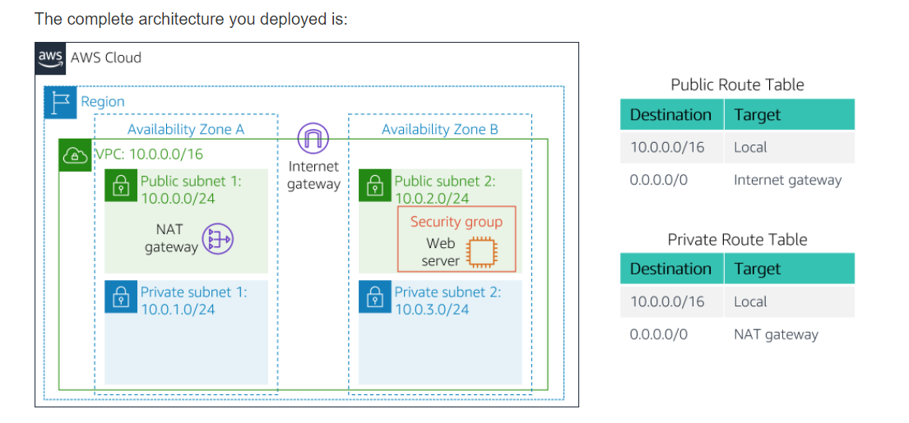

# You will do the following to meet the specification provided on the above diagram:

# Create a VPC with subnets (1 points)

# Create routing table entries (1 points)

# Configure a security group (1)

# launch an ec2 instance on VPC and access through your browser (5 points)

# Create VPC and the Subnets:

# ----------------------------

# 1. Open the VPC service from AWS Management Console

# 2. Launch VPC

# 3. Create a public ip

# 4. Select 'vpc wih public and private subnets' from left panel

# - vpc name: OPBIT

# - public subnet name: Public Subnet 1

# - select the first availability Zone

# - private subnet name: Private Subnet 1

# - select the first availability Zone

# - pick the elastic ip

# 5. Create two more subnets

# - select subnets from left panel

# - select the VPC you created

# - Select second availability Zone for this

# two subnets: Public Subnet 2 and

# Private Subnet 2

# - put corresponding CIDR for these

# two subnets (Refer to the diagram)

# Create Routing Tables for private and public clouds

---------------------------------------------------------------------------

6. Create Routing Tables

- from left panel select Route Table

- Select the route table that has

Main=Yes and VPC=OPBIT

- Name this route table as Private Routing Table

- Change the subnet association to

Private subnet 1 and Public Subnet 1

7. Repeat step 6 for creating Routing Table for Public Subnets

- Select Main=No and VPC=OPBIT

Create Security Group

======================

Create the security group that allows inbound traffic to http

Launch a Web server instance

================================

Select the Amazon Linux 2

Select t2.micro

Configure instance details:

- set the instance at the public subnet 2 you created

- Copy and paste the following code as User data from

Advanced Details

|  |
| --- |
| #!/bin/bash  # Install Apache Web Server and PHP  yum install -y httpd mysql php  # Download Lab files  wget https://aws-tc-largeobjects.s3.amazonaws.com/AWS-TC-AcademyACF/acf-lab3-vpc/lab-app.zip  unzip lab-app.zip -d /var/www/html/  # Turn on web server  chkconfig httpd on  service https start |

Add Storage

Add Tag

Attach the security group you created early.

---------------------------------------------

**Submission:**

Paste the screen shot of the webserver accessed through from your web browser.

